Tolerance Mapping – Partition Wall Case Revisited
Colin Milberg and Iris D. Tommelein

Abstract
Geometric tolerances within a component and assembly combine to form closed loops based on the work structure, i.e. the geometry, function, construction methods and construction sequence of the component, assembly or system. A tolerance loop is by definition over-constrained. Tolerance loops can cause fit-up or functional problems if the tolerances within the loop are inconsistent. Inconsistency is common because geometric tolerances are not given due consideration in civil systems design and construction.
Milberg and Tommelein (2003) demonstrated how a combination of tolerance mapping and tolerance management techniques from manufacturing research applied to the case of a simple partition wall can help designers represent tolerance loops for different system work structures. This tolerance mapping technique applied to the same case is herein expanded to include representations of the magnitude of each tolerance and their degree of influence on the loop closure. Tolerance principles of datum reduction and consistency are also applied.

Keywords
Tolerances, Constructability, Work Structuring, Lean Construction

Introduction
Milberg and Tommelein (2003) identified a lack of understanding and attention by AEC practitioners to the impacts of geometric tolerances on the quality, duration and cost of AEC projects. Tolerances can impact project quality when they are exceeded and accepted because rework is too costly. Tolerances can impact project duration and cost when rework, additional processes or more time consuming and costly processes are required to meet project tolerances. Tolerances are exceeded because the design tolerance is tighter than the associated process capability, the accumulations of the individual component tolerances specified exceed the assembly tolerance, the communication of tolerance constraints are unclear or non-existent, or there is a lack of care in process execution.
AEC practitioners lack understanding of and give little attention to tolerances for several reasons. First is the lack of data on geometric variation in AEC processes, process capabilities. Second is the lack of clarity in who is responsible for managing tolerances. The tendency is to push the responsibility downstream and rely on skilled labor and rework. Third is the current practice for accounting for costs. Practitioners rely on traditional strategies to absorb geometric variations. These strategies are assumed as necessary and the associated costs are not individually tracked. We are left with no means to compare the impacts of alternative strategies. Fourth is the difficulty in visualizing and describing geometric variations and their accumulation.
In manufacturing there are standards for tolerance specification and interpretation as well as tools for tolerance analysis and allocation which evaluate tolerance accumulation and aid in visualization. Adapting these tools for use in civil engineering seems a logical first step for improving tolerance management in architecture, engineering and construction (AEC). The accumulation of tolerances through an assembly or series of processes is defined by the assembly function. Table 1 shows the design decisions that impact the assembly function and the AEC project phase in which they are typically determined.
Table 1: Assembly Function Decisions and Project Phase (Gerth 1997 and Soderberg and Lindkvist 1999)
Assembly Function Design Decisions | Project Phase
Feature and Assembly Tolerance Specification | Product Design
System Geometry | Product Design
Datum Priority | Distributed, All Phases
Connection Types | Product or Process Design
Fabrication/ Construction Means and Methods | Process Design, Fab. and Construction
Process Sequence | Process Design and Construction
Work-structuring is the process of breaking work into chunks, assigning them, sequencing them, and defining their handoffs between production units (Ballard et al. 2001). Typical project work-structure would execute product design by a designer, process design by a contractor, fabrication by fabricators and construction by the contractor in that order. However, this work-structure may not be the most efficient for all projects. Constructability research has shown that decisions regarding construction means and methods may have a greater influence on project cost, schedule, and quality than product design decisions (CII 1993). The point is that all these decisions are interdependent. Accumulation of tolerances is one way in which these decisions are interdependent. Also, individual process work-structures are what determine construction means and methods and process sequence. Therefore accumulation of tolerances should be a consideration in the work-structuring of the project both in terms of the major project phases and the work-structuring of processes within a given phase.
Tolerance networks (Tsai and Cutosky 1996) are a tool for graphically representing the path of tolerance accumulation based on a product component breakdown. Milberg and Tommelein (2003) adapted tolerance networks to capture the flow of geometric tolerances associated with a given process work-structure. For a given work-structure, the tolerance maps help engineering practitioners to:
- identify tolerance loops or over-constrained sets of tolerances
- identify functional tolerance constraints that may not be directly measured or controlled during manufacturing, construction and inspection.
- identify inconsistencies between the specification of tolerances for individual components and assemblies, i.e. tolerance loops
- identify inconsistencies between tolerances and process capabilities
- make comparisons to alternative product designs, process designs and work-structures.
Milberg and Tommelein (2003) used the mapping system to compare different work-structures used for the installation of a partition wall with an embedded outlet box. In this paper the mapping system has been updated to include more work-structure and tolerance information. The paper will describe and discuss the updates. The paper will also show how some basic tolerance management principles can be applied to select among or generate new process work-structures for the partition wall example. The new work-structures will be evaluated with the aid of the mapping system.

Case Review
The partition wall example illustrates the impact that tolerances can have on the installation of a standard stud partition wall containing an electrical box for a switch or outlet (Figure 1).Tolerances accumulate through variations in the studs themselves, the placement of the studs, the electrical box itself, the placement of the electrical box, the outlet plate itself, the placement of the outlet plate, the drywall sheets themselves, the cutting of the hole in the drywall, the placement of the drywall and the layout of each of these components or features. One problem that can result is illustrated in Figure 2 and 3. Details of tolerances for each component and the assembly of a wall are described in Milberg and Tommelein (2003).
Reference
Wall
Surface
Floor Plate
Floor Surface
Drywall
Hole in Drywall and Outlet Box
Global Datum Reference Frame (DRF)
Stud
Z
X
Y
Figure 1: Partition wall with outlet
 |  | 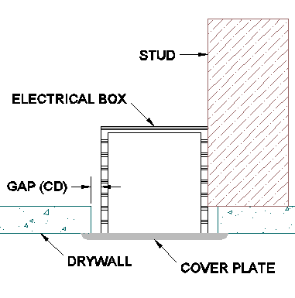
Figure 2: Hole in the drywall exceeds the limits of the outlet plate | Figure 3: Orientation of Hole in the drywall doesn’t match box/outlet orientation | Figure 4: Figure 1 Section View, Looking Down, Taken at the Center of the Electrical Box

Tolerance Principles
In design the location of various components are specified. Typically it is not the location of components that is important but the relationship between design components or objects in the field. For example in the design of a building frame the location of each column is not as important as the relative distance between them determining the load carried by each. The allowable variations in the dimensional relationship between design components are tolerances.
Tolerances are referential by definition. For a component feature, geometric and dimensional tolerances (GD&T) are the description of a variation from a nominal geometry. The nominal geometry is the datum or theoretically exact reference geometry such as an axis, plane or straight line. All features within a part or component should be fully constrained, i.e. have uniquely defined locations within a defined reference frame (coordinate system). If a feature is not fully constrained, then it is unnecessary, as it could be located off the part and thus no longer be a feature of the part. Therefore every feature of a given part will be referenced to the parts datum reference frame (DRF) or another feature within the part or another part in the assembly. Similarly, for an assembly, features from one part are referenced to features in other parts to form the assembly or to the assembly DRF. Any feature that is used as reference geometry is also called a datum feature. Standards determine the theoretically exact geometry that replaces a datum feature and is used to define the nominal geometry of an associated feature. The references between features are in the form of dimensions, linear and angular, from the datum feature’s substituted exact geometry that locate the nominal geometry for the other feature, combined with tolerances (dimensional constraints) relative to that nominal geometry (Henzold 1995).
Milberg and Tommelein (2003) described the relationship between size, form, orientation and location tolerances based on the conventional GD&T system (Figure 5). In this paper the vectorial dimensioning and tolerancing (VD&T) system will be used (Figure 6). In the GD&T system form, orientation and location tolerances are hierarchical. Location tolerance zones limit orientation tolerance zone limits which limit form tolerance zone limits. In the VD&T system, location, orientation, and form tolerances are cumulative. The substitute elements in the VD&T system represent the theoretical exact geometry similar to the nominal geometry of the features, in this case lines. The location and orientation of the geometry (best fit line) can be determined by different methods including the Gauss method, minimizing the sum of squares deviations of the form deviations and the Chebyshev method, minimizing the maximum deviations of the form deviations (Henzold 1995). For this paper we have selected the Chebyshev method as it is similar to the method used in the GD&T system.
In the vectorial system components have a DRF defined by its primary, secondary and tertiary datum features. In figure 6 the primary datum is the plane defined by the page, call it XY, that defines the Z-axis. The secondary datum is the datum feature substitute element line which defines the X-axis. This line could also represent the intersection line of a secondary datum plane, XZ, with the primary datum. The y-axis is perpendicular to the X and Z axes. The origin location of the DRF is located by a tertiary datum. In figure 6 the tertiary datum is the right edge of the datum feature (not labeled) and the origin was specified at 2/3 the length of the datum feature substitute element. The origin completes the DRF definition.
Nominal Location  Datum  Orientation  Deviation  Form  Deviation  Max +  Location  Deviation  Max –  Location  Deviation  Datum Feature  Feature  2X Location  Tolerance  Nominal Geometry | Substitute Distance  (Location)  Datum  Feature Substitute  Element  Form Deviation  Datum Feature  DRF  Origin  Feature Substitute Element  Feature  Nominal Geometry  Orientation Deviation
Figure 5: GD&T System (Henzold 1995) | Figure 6: VD&T System (Henzold 1995)
The feature nominal geometry and tolerances are specified from the DRF. In the case shown in figure 6 the dotted line represents the feature’s nominal geometry. A location vector (the substitute distance in figure 6) describes the location of the origin of the feature’s nominal geometry from the DRF origin. Location tolerances are described as the maximum deviations from the location vector in each component direction of the DRF. A unit orientation vector at the origin of the nominal geometry describes the orientation of the nominal geometry. Planes are oriented perpendicular to the orientation vector and lines or axes are oriented parallel to the orientation vector. In figure 6 the dotted line is the orientation vector. Orientation tolerances can be specified by linear or angular dimensions. Angular orientation tolerances are described as maximum rotations of the feature’s nominal geometry about the feature’s origin about each of the DRF axes. Linear Orientation tolerances are described as maximum deviations from the orientation vector in each component direction of the DRF. The actual orientation deviation of the nominal geometry about its origin defines the feature’s substitute element. The form tolerance is specified as a total distance centered on and measured perpendicular to the feature’s substitute element. A refinement of the form tolerance, waviness, has a smaller length to depth ratio than the main form tolerance. Waviness is also specified as a total distance perpendicular to and superimposed over the form tolerance. Further refinement in specification of roughness can also be made which is superimposed on the waviness. For circular surfaces (spheres, cylinders, cones and tori) the location and orientation vectors apply to the axes or centers of the surfaces. An additional size specification and size tolerance are necessary. Sizes and size tolerances are always perpendicular to the orientation of the surface axis.

Tolerance Networks
References between features, datum features, DRFs and datum can be represented graphically in the tolerance network tool (Tsai and Cutkosky 1996). The network represents features, datum features and datum as network nodes; the connectors between nodes have a symbol associated with them that represent the type of geometric constraint between the features. These constraints may or may not include a tolerance associated with the functioning of the part or assembly. The network represents the product design intent for the constraints.
Figure 7 is the key for the different symbols in the network. The node at the starting end (datum side) of a connector is a datum, DRF, or datum feature. The node at the arrow end (feature side) of a connector is another datum, DRF, or feature. A node can be at the starting end of one or more connectors and at the arrow end of one or more other connectors meaning the node can be both a feature of a component and a datum feature for another node. When nodes and connectors form a loop it indicates that the features in the loop may be over-constrained. Using numerical tolerance analysis tools and assigning tolerance values to the connectors between nodes, the loop can be checked for consistency. A loop is consistent if starting at any node the worst case accumulation of tolerances through every node does not exceed the allowable tolerance for the connector between the first and last node (Tsai and Cutosky 1996). Accumulation may also be calculated by statistical means if preferred.
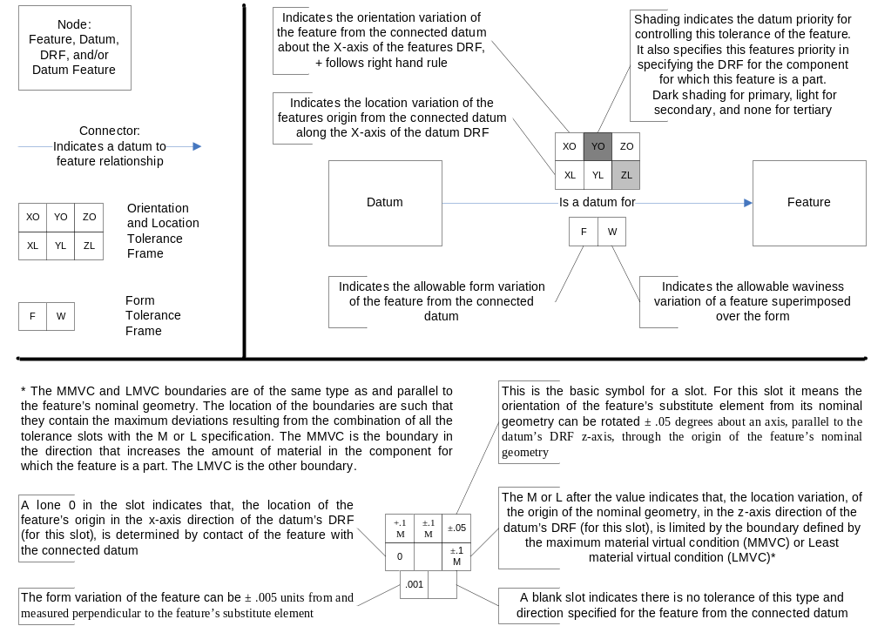
Figure 7: Tolerance Network Map Key
Tolerance values are assigned to the connector using tolerance frames which have different slots for different tolerance variations. The value in the slot represents the tolerance, the allowable deviations from the nominal location and orientation vectors. The nominal values specified by the location and orientation vectors are not graphically shown on the map for clarity but are recorded as they impact the accumulation of variations among features.

Partition Wall Tolerance Networks
Milberg and Tommelein (2003) used an earlier version of the adapted tolerance network described above to represent process design and sequencing information for the partition wall case. Three alternative sequences (work-structures) were compared. Work-structure one was taken from a process perspective, optimizing each task in the sequence and minimizing the number of tasks. The hole in the drywall was positioned relative to the edges of the drywall based on the nominal positions of the edges and the hole. This allowed the holes to be pre-cut away from the work-face in an efficient manner. Work-structure two still cut the hole relative to the drywall edges but delayed the cutting until the box was installed. This allowed the actual position of the box to be measured relative to the datum for the drywall edges. The hole could still be cut away from the work-face from the drywall edges but the cutting is now coupled to the box installation and the extra step of measuring is required. Work-structure three involved: putting the drywall in position; pressing it against the box; taking it down and cutting the hole at the marks made by the box. In this case the cutting is done less efficiently at the work-face and the marking is even less efficient than measuring. Comparing the networks for the three work-structures for the accumulation of tolerances illustrated the benefits of two tolerance principles, reducing the number of datum in a loop (between work-structure 1 to 2 and 1 to 3) and reducing the magnitude of the tolerances (between work-structure 2 to 3). Work-structure 3 was the one that always prevented the problem shown in figure 1 and the associated rework or loss in quality.
Figure 8 shows most of the design tolerance network for the partition wall case. The tolerance network shown represents the product design. No process design information is included but some work-structuring information is included. Nodes outlined in the same color are part of the same physical component or family of components. The color of the connector indicates the trade or company responsible for controlling the tolerances and relationship defined by the connector and tolerance frames. This design network (figure 8) shows that work-structure 3 illustrated another tolerance management principle, consistency of datum between design (function), manufacturing and inspection (Henzold 1995, Tsai and Cutkosky 1996, Gerth 1997 and Soderberg and Lindkvist 1999).
A designer should be able to assess several important points from the tolerance network in figure 8. First, is that the edges of the holes in the drywall which are features of the drywall are not directly connected to the drywall DRF. When this happens it means that the trade or company responsible for handling that component (the drywaller in this case) may have to be interrupted by another trade before completing their work associated with that component in order to meet the design tolerances. From a process design perspective such conditions are undesirable because they increase the number of handoff and the degree of coupling between activities (Howell et al. 1993). In this case, the process sequence that is consistent with the design datum sequence is not even feasible.
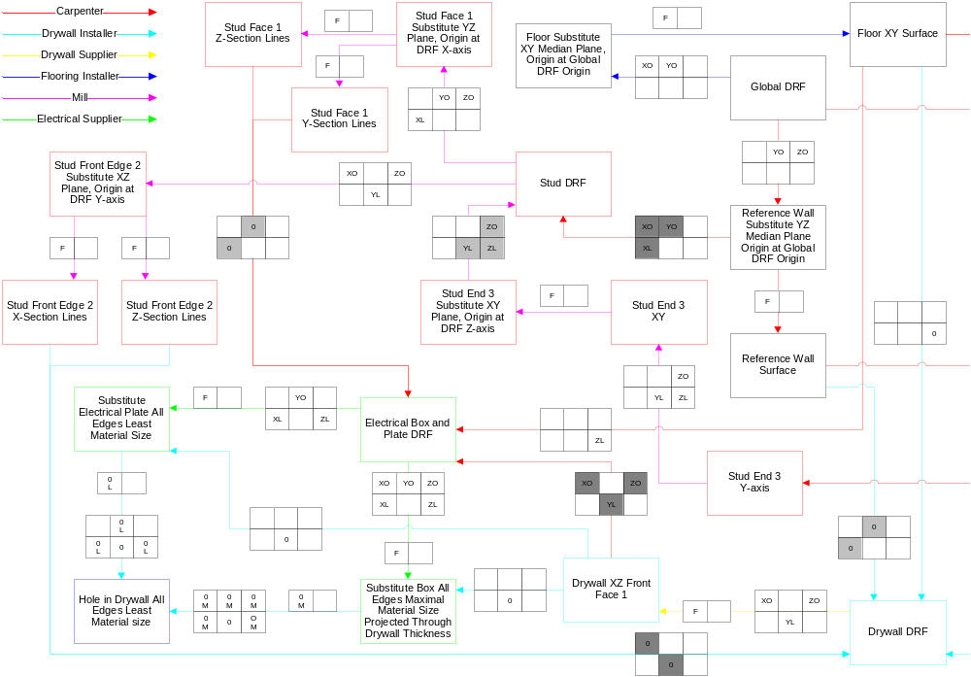Figure 8: Partition wall with outlet box partial design tolerance network
The hole in the drywall shares the electrical box and plate DRF. The electrical box derives part of its DRF from the drywall DRF. This means that for the process to be consistent with the design datum sequence, the drywall should be installed first; the electrical box and plate should be installed second; and the hole should be cut in the drywall third. This sequence is not feasible because the drywall installation would prevent access to the box installation and without a hole the box will prevent installation of the drywall. Of the three work-structures presented by Milberg and Tommelein (2003), work-structure three comes the closest to being consistent with the design datum sequence. In work-structure 3 the box is installed first. This is not too much of a deviation as the drywall only controlled part of the box DRF in the design network. Then the drywall is held in the position of its final installation in every respect but the Y location due to the box. In this way the hole DRF is that of the electrical box which is consistent with figure 8. In the other work-structures the drywall DRF is used for the hole. In this way the tolerance network identifies locations where the tolerance constraint specified cannot be directly controlled.

Further Advantages and Applications of tolerance networks
It is also useful to create process tolerance networks. By comparing process networks to the design network it is easier to identify where processes cannot or are preferably not consistent in the datum path. Also, the process network should include process capability data in the tolerance frames instead of design tolerances. This way the values of the process capabilities can be compared to the design tolerances. Designs should be avoided where the design tolerance is tighter than the process capability. This will result in failure to meet the tolerance and potential rework and delays. However, if the process capability is tighter than the design tolerance, there is potential to use a less precise process which is typically less expensive and/or the tolerances can be reallocated to prevent tolerances being tighter than the process capability in other locations. By having both networks communication is facilitated between designer and the contractor or fabricator to come up with an integrated solution or to compare among alternative solutions.
Currently however, there is a lack of explicit construction process capability data (Milberg and Tommelein 2003-A). The argument for not collecting this data is that process capabilities vary too much from one job to the next. Without collecting it, how will we know if it varies or what factors cause it to vary? However, benefit can be gained even from the rough estimates of process capability.
Another use of the tolerance network is identifying tolerance loops. In figure 8 there are no tolerance loops shown. Although the connectors visually form loops, no feature or component DRF has the same degree of freedom (X, Y, Z - location and orientation) controlled by multiple datum. If for example, the location of the hole in the drywall was also dimensioned and toleranced from the drywall edges, then a loop would be formed. The design would be over-constrained as the hole’s location is controlled both by the drywall DRF and the electrical box DRF.
If the loop is established then tolerance analysis should be used based on the data in the network to make sure that the total variation in the location of the hole according to the datum sequence through the electrical box DRF starting at the drywall edges does not exceed the allowable deviation in location relative to the drywall DRF, or vice versa. As long as the cumulative variations starting at a node in the loop and ending in the node connected the starting node opposite the direction of travel does not exceed the tolerance associated with the connector between the starting and ending node the loop is consistent.
A simpler example of a loop is the dimensioning of columns for a building. If the dimension between each of a set of more than 2 columns is specified with certain tolerances, and the overall dimension form the first and last column is also specified with a certain tolerance, the cumulative tolerance of the dimensions between adjacent columns cannot exceed the tolerance specified between the first and last. Otherwise the system or loop is inconsistent.
The design tolerance network includes more specific information about design intent than is typically found in AEC design drawings and specifications because they use the rules established by the standards for GD&T and VD&T. In AEC we lack standards for specification of datum and tolerances. This leads to misinterpretation of the designer’s intent. Using the column example, if the location of the columns is represented by a series of center to center dimensions with no overall dimension does this mean that the spacing between studs is more important than the overall dimension from the face of the first to the face of the last column? Many would say yes but there is no AEC standard. Certainly there are recommendations for dimensioning in some codes and specifications but they are only recommendations. In one author’s experience disagreement on the interpretation is frequent. The ambiguity in practice undermines the specification of tolerances, quality control and designer-contractor relations (Birkeland et. al 1971). Also, because tolerance networks allow clear communication of design intent and specifically avoid unnecessary constraints they help facilitate concurrent engineering and set-based design.

Acknowledgments
This research was funded by grant CMS-0116877 from the National Science Foundation, whose support is gratefully acknowledged. Any opinions, findings, conclusions, or recommendations expressed in this paper are those of the authors and do not necessarily reflect the views of the National Science Foundation.

References
Ballard, G., Koskela, L., Howell, G., Zabelle, T. (2001). “Production System Design: Work Structuring Revisited.” White Paper #11, Lean Constructon Institute, 14 pp. (available at http://www.leanconstruction.org).
Birkeland, P.W. and Westhoff, L.J. (1971). “Dimensional Tolerances in a Tall Concrete Building.” J. or the American Concrete Inst., ACI, Detroit, 68 (8) 600-607.
Bjork, O. (1989) Computer Aided Tolerancing. New York: ASME Press.
Chase, K.W., Greenwood, W.H., Loosli, B.G., and Hauglund, L.F. (1990) “Least cost Tolerance Allocation for Mechanical Assemblies with Automated Process Selection.” Manufacturing Review, v. 1 (1), pp. 50-59.
CII (1993). Constructability Implementation Guide. CII Special Pub. 34-1, Univ. of Texas, Austin, Texas, 277 pp.
Derucher, K.N. and Korfiatis, G.P. (1988). Materials for Civil and Highway Engineers. Prentice Hall, New Jersey.
Henzold (1995). Handbook of Geometrical Tolerancing. Wiley & Sons, England, 413 pp.
Houten, F. and Kals H. (eds.)(1999). Global Consistency of Tolerance: Proceedings of the 6th CIRP Int. Sem. on Computer-Aided Tolerancing. Univ. of Twente, Enshede, Netherlands, March. Dordrecht, The Netherlands: Kluwer Academic Publishers.
Howell, G., Laufer, A., and Ballard, G. (1993) “Interaction Between Subcycles: One Key to Improved Methods.” J. Construction Eng. and Mgmt., ASCE, NY, 119 (4) 714-728.
Kubal, M.T. (1994). Engineering Quality in Construction. New York: McGraw-Hill.
Kusiak, A. (ed.) (1993). Concurrent Engineering: Automation, Tools and Techniques. New York: Wiley & Sons.
Milberg, C.T., Tommelein, I.D., and Alves, T. (2002). “Improving Design Fitness Through Tolerance Analysis and Allocation.”Proc. Concurrent Engrg. in Construction Conf., U.C. Berkeley, CA, 181-193.
Milberg, C.T and Tommelein, I.D. (2003). “Application of Tolerance Analysis and Allocation in Work Structuring: Partition Wall Case.” Proc. 11th Annual Conference of the International Group for Lean Construction, 22-24 July, Blacksburg, VA.
Milberg, C.T. and Tommelein, I.D. (2003-A). “Role of Tolerances and Process Capability Data In Product and Process Design Integration.” Proc. Constr. Research Congress 2003, Mar. 19-21, Hawaii, ASCE. 8 pp.
Prasad, B. (1996). Concurrent Engineering Fundamental, Vol. 1. NJ: Prentice Hall PTR.
Reader’s Digest Staff (1991) New Complete Do-it-yourself Manual. Reader’s Digest Association, Inc., Pleasantville, NY, 528 pp.
Schmenner, R.W. (1993). Production/Operations Management. Prentice Hall, NJ.
Taguchi, G., Chowdhury, S., and Taguchi, S. (1999). Robust Engineering. McGraw-Hill, NY.
Tommelein, I.D. (2000). “Impact of Variability and Uncertainty on Product and Process Development.” Proc. Constr. Congress VI, Feb. 20-22, Orlando, FL, ASCE, 969-975.
Tsai, J., Cutkosky, M.R. (1997). “Representation and Reasoning of Geometric Toleraces in Design.” Artificial Intelligence for Engrg. Design, Analysis and Manfacturing, Cambridge University Press, 11, 325-341.
Trabelsi, A. and Delchambre, A. (2000). “Assessment on Tolerance Representation and Tolerance Analysis in Assemblies.” Concurrent Engineering: Research and Applications. Technomic Publishing Co., Lancaster, PA, Dec., 8 (4) 244-262.
USG Co. (2003). “Installation and Finish Guide.” Technical Report J371 rev. 2-03, United States Gypsum Company, Chicago, IL., 26 pp. (available at http://www.usg.com)
Wakita, O.A., Linde, R.M. (1994). The Professional Practice of Architectural Working Drawings. Wiley and Sons, Inc., NY.
Walsh, K.D., Bashford, H.H., and Mason, B.C.A. (2001). “State of Practice of Residential Floor Slab Flatness.” Journal of Performance of Constructed Facilities, ASCE, New York, NY, 15 (4) 127-134.
Zhang, G. (ed.)(1997). Advanced Tolerancing Techniques. Wiley & Sons, NY.

PhD Candidate, Civil and Envir. Engrg. Department, 215 McLaughlin Hall, Univ. of California, Berkeley, CA 94720-1712, 510/289-2552, FAX 510/643-8919, cmilberg@ce.berkeley.edu
Professor, Civil and Envir. Engrg. Department, 215-A McLaughlin Hall, Univ. of California, Berkeley, CA 94720-1712, Phone +1 510/643-8678, FAX 510/643-8919, tommelein@ce.berkeley.edu

